docker pull docker.io/vldbuk/gpdb_demo_repo:gpdb_demo
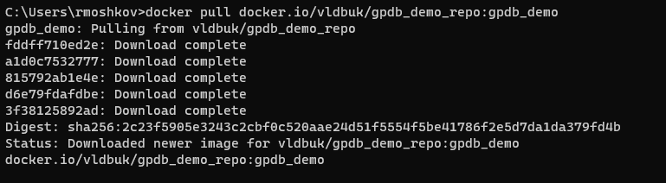

docker images
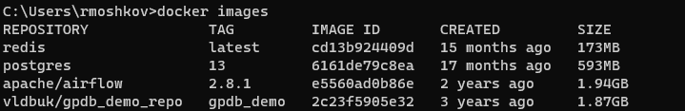

docker run -ti -d --privileged=true -p 5432:5432 docker.io/vldbuk/gpdb_demo_repo:gpdb_demo "/usr/lib/systemd/systemd"

docker ps
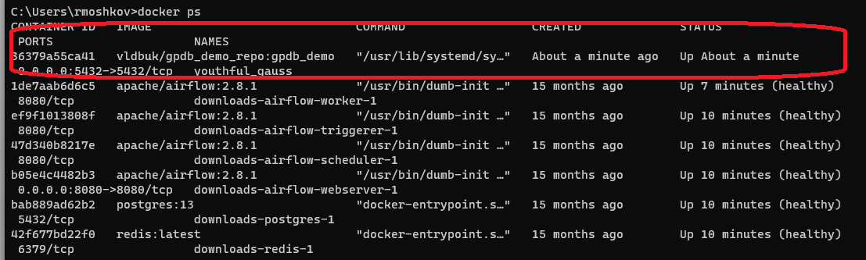

docker exec -it 36379a55ca41 bash
su gpadmin
gpstart -qa
psql -d demo
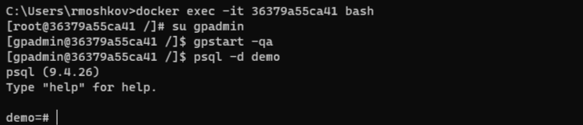

select now();
select version();
select * from gp_segment_configuration;
